ACA Module 10: Automating Infrastructure Deployment with AWS CloudFormation

Student name: Duy Hung D Student ID: 104182779

Tutorial session: Monday 1:00PM

1. INTRODUCTION

Automating Infrastructure Deployment with AWS CloudFormation revolutionizes the process of provisioning and managing resources in the cloud. AWS CloudFormation is a powerful Infrastructure as Code (IaC) service that allows users to define and deploy infrastructure in a programmatic and reproducible manner. By describing the desired state of their AWS resources in a declarative template, users can efficiently create and manage complex infrastructures with just a few clicks. This automation not only enhances speed and consistency in deployment but also ensures that infrastructure changes are traceable and auditable. AWS CloudFormation streamlines the orchestration of various AWS services, providing a scalable and efficient solution for organizations looking to optimize resource provisioning and management in the cloud.

1. Main

**Task 1: Deploying a networking layer**

Download the lab-network.yaml template to the computer. Templates can be composed in JavaScript Object Notation (JSON) or YAML Ain't Markup Language (YAML). YAML is a markup language that closely resembles JSON, however, it boasts a more effortless readability and editing capability.

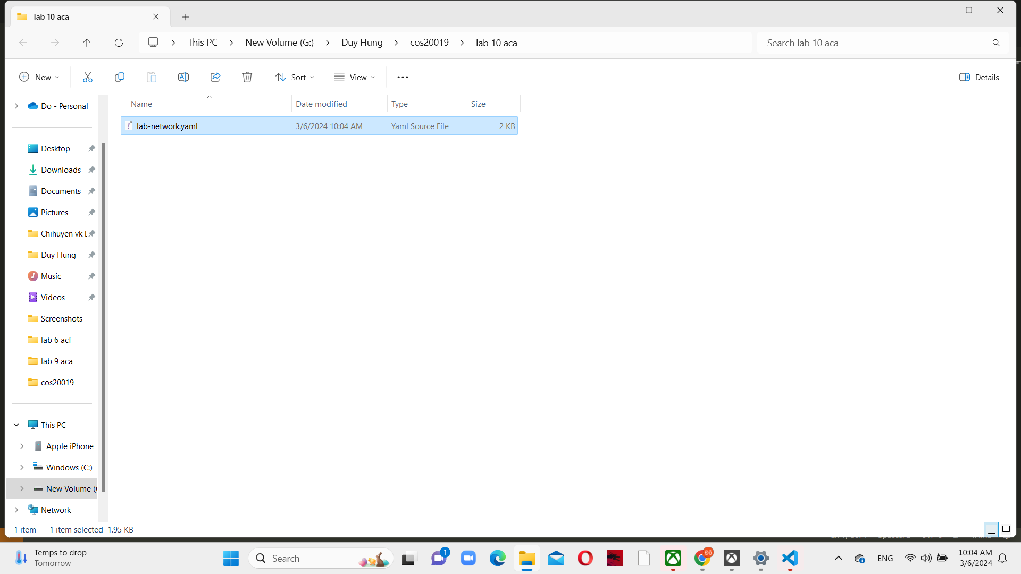

*Figure 1 Downloaded template on the computer*

Choose CloudFormation from the Services menu in the AWS Management Console, and then create a new stack.

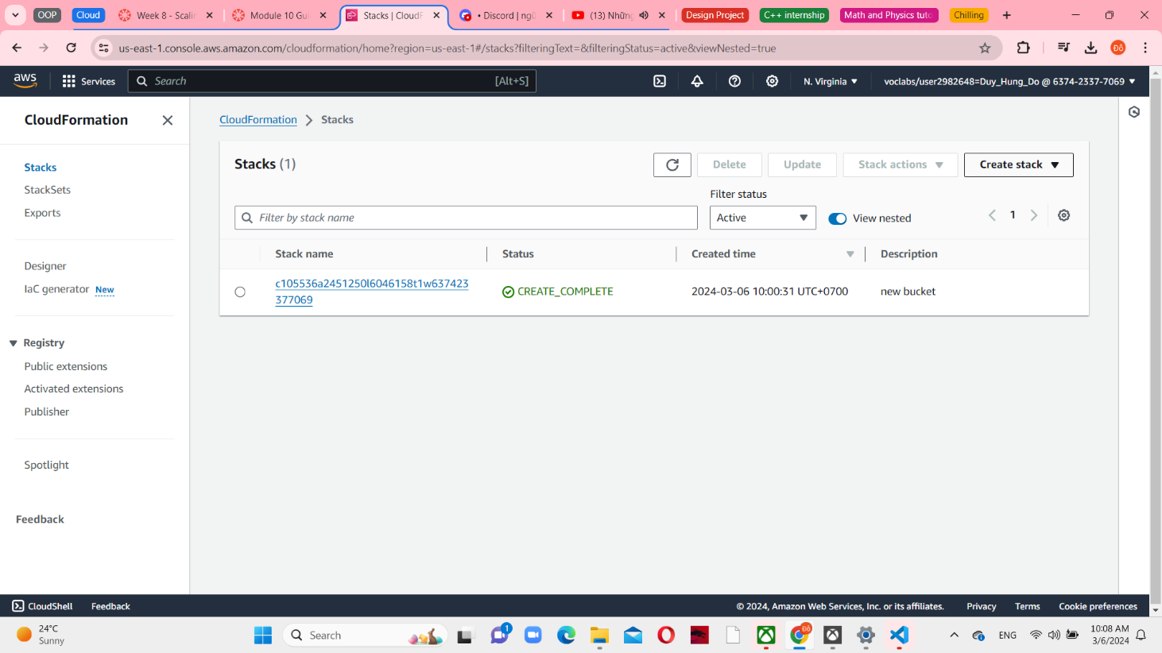

*Figure 2 Stacks in CloudFormation*

In step 1, set a Upload a template file in the template source and upload the lab-network.yaml file as a template file.

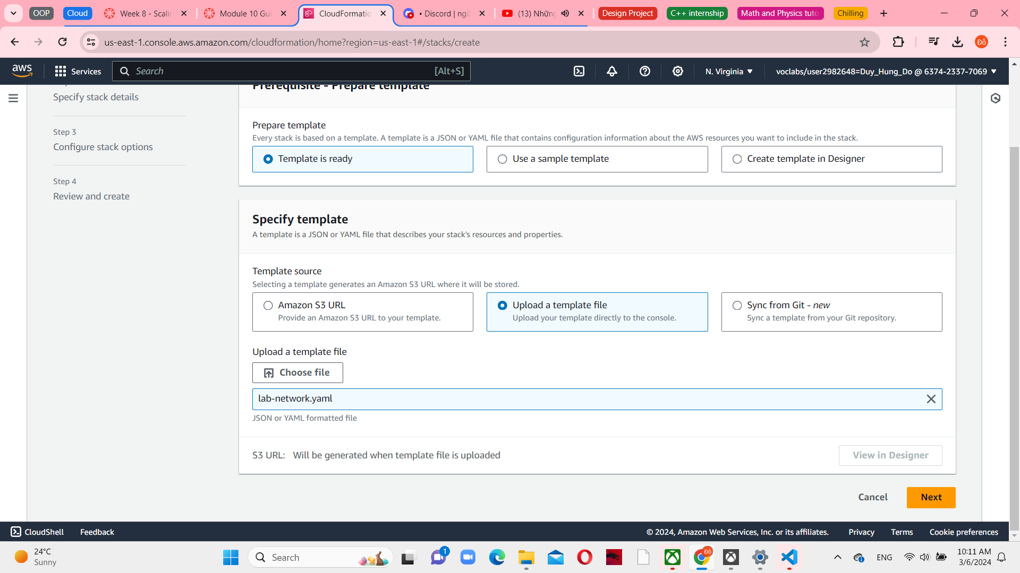

*Figure 3 Specify template*

In step 2, set “lab-network” as a stack name and then choose next to step 3.

*Figure 4 Specify stack details*

In step 3, add new tag and configure the key is application and the value is inventory.

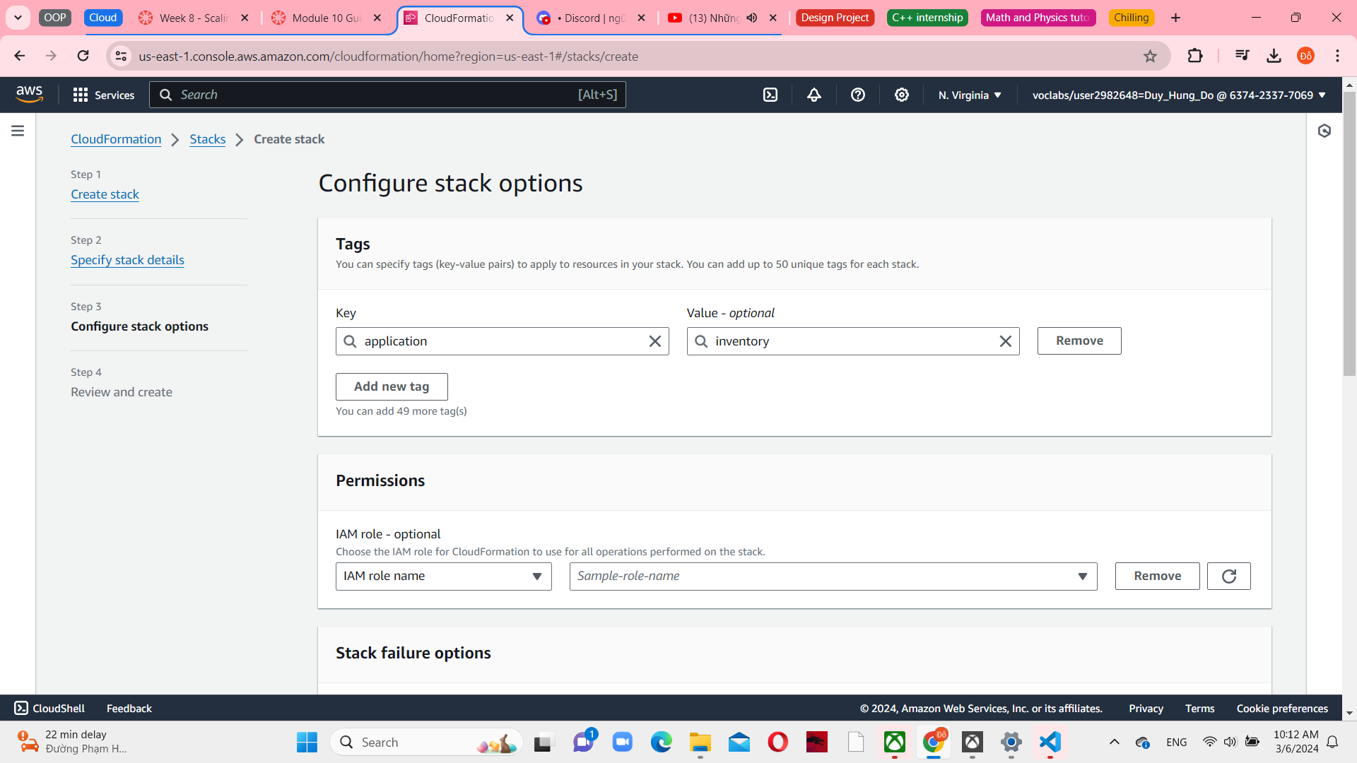

*Figure 5 Configure stack options*

In step 4, review lab-network. The AWS CloudFormation will now utilize the template to produce a stack of resources within the AWS account. The resources that are created will automatically inherit the specified tags, simplifying the identification of resources utilized by specific applications.

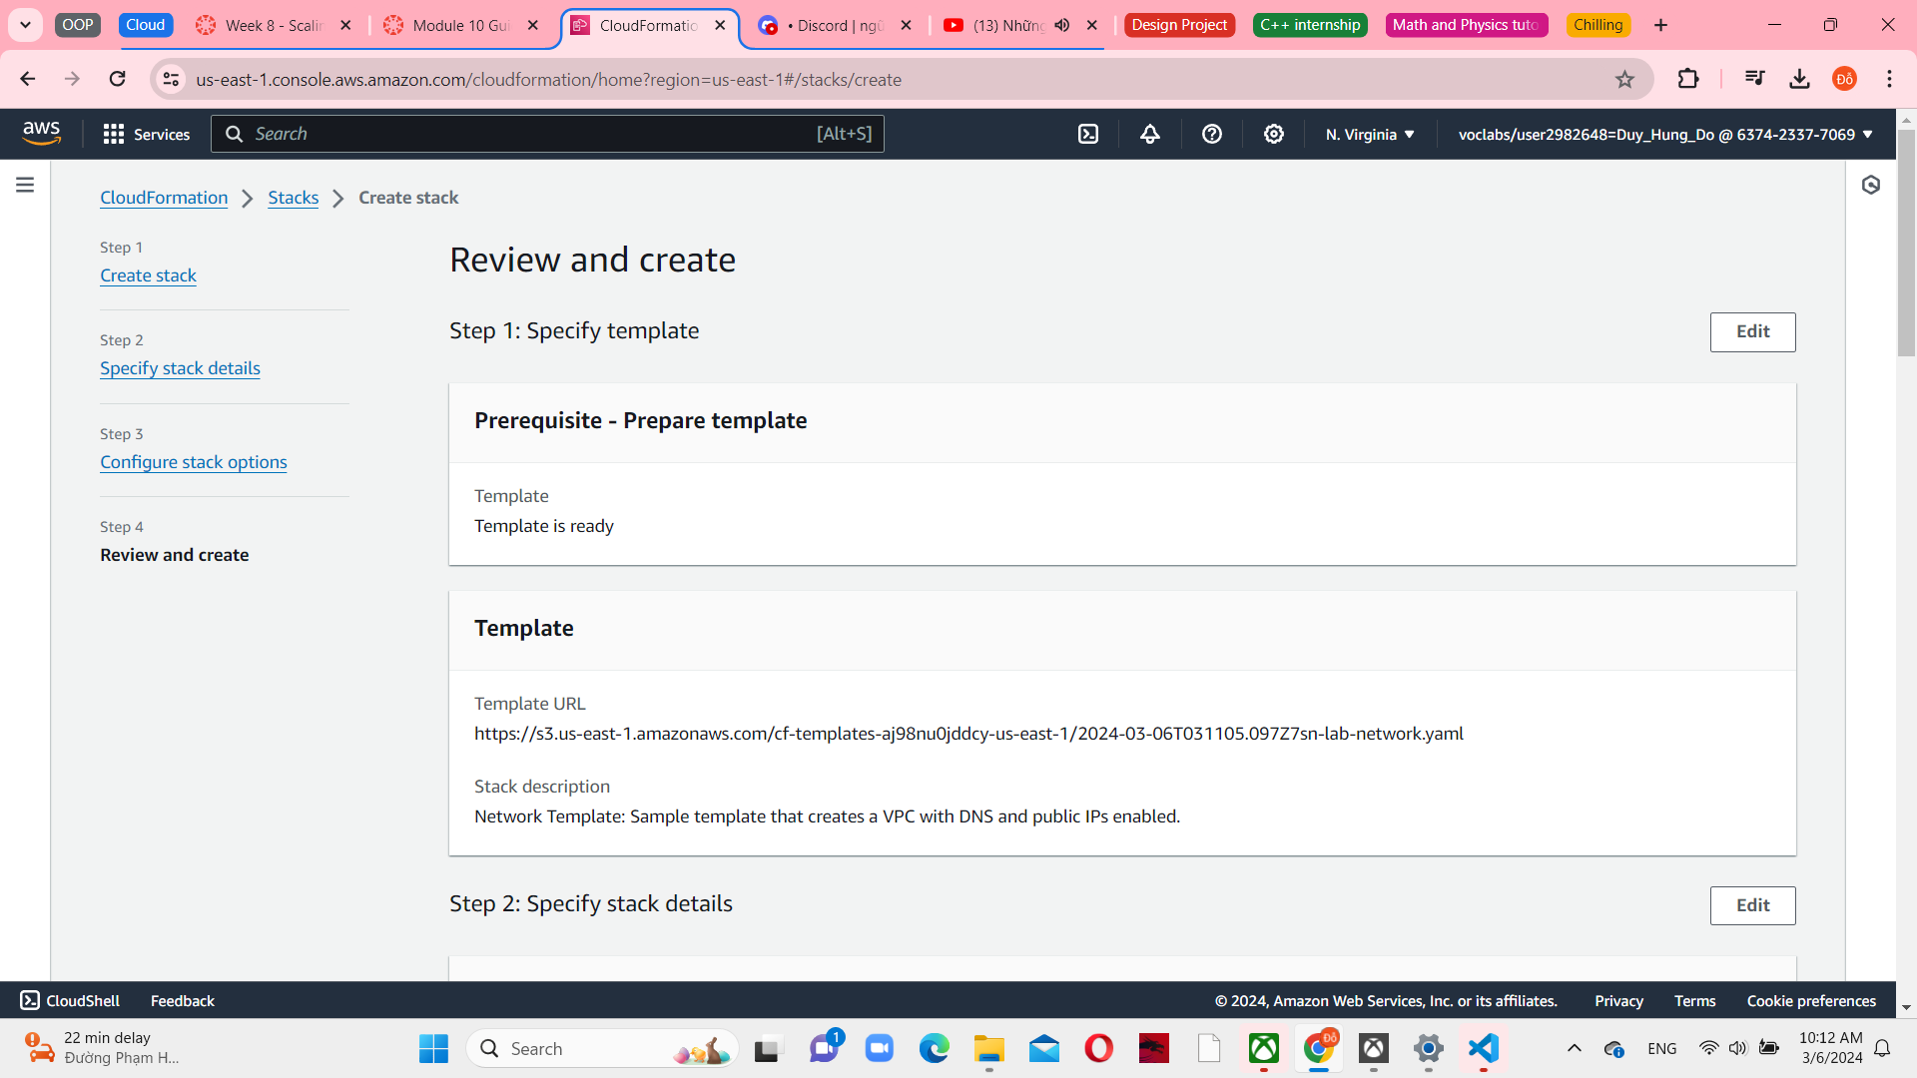

*Figure 6 Review stack*

Choose the Stack info tab and wait to create stack complete.

*Figure 7 Creating stack in progress*

Until creating complete choose the Resources tab to see a list of the resources that were created by the template.

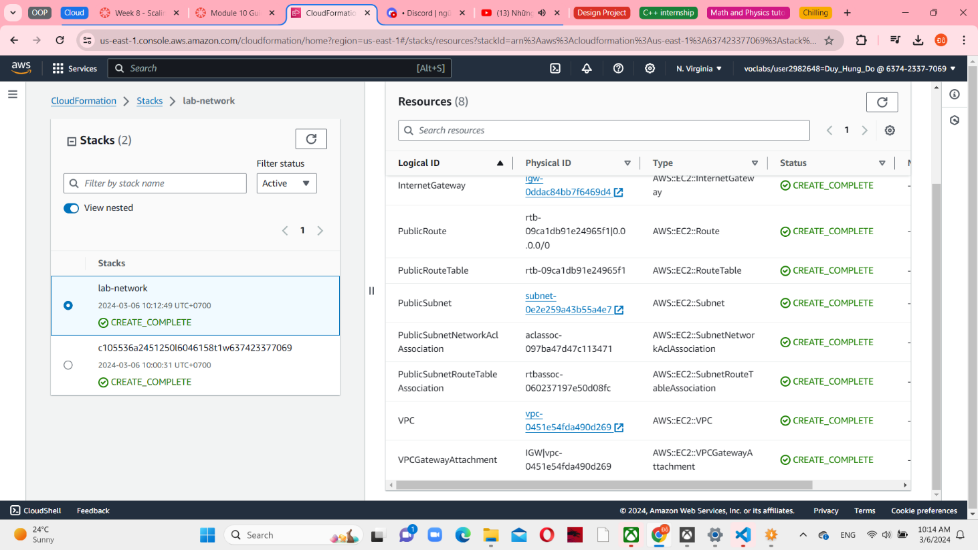

*Figure 8 Stack resources*

Choose the Events tab and scroll through the events log. The events log displays a chronological order of the activities carried out by AWS CloudFormation, with the most recent events appearing first. These events encompass various actions, such as initiating resource creation and successfully finalizing the creation process. Any errors that occurred during the stack creation will be documented in this section.

*Figure 9 Stack events*

Choose the Outputs tab. The Public Subnet and VPC are listed. Outputs can be utilized to furnish values to additional stacks. This is exemplified in the Export name column. In this instance, the VPC and subnet IDs are assigned export names to enable retrieval of the values by other stacks. Subsequently, these other stacks have the capability to construct resources within the VPC and subnet that have recently been established.

*Figure 10 Stack outputs*

Choose the Template tab. The tab displayed showcases the template that was utilized in forming the stack. This template refers to the one you uploaded during the stack creation process. Please feel at ease to inspect the template and observe the resources that were established. Additionally, feel free to explore the Outputs section located at the end. This section defines the values that are to be exported.

*Figure 11 Stack templates*

**Task 2: Deploying an application**

Download the lab-application.yaml and then choose Stacks in the left navigation pane. Select With new resources (standard) in Create stack menu.

*Figure 12 Create stacks with new resources*

In step 1, select Upload a template file in Template source and upload the lab-application.yaml file as a template file.

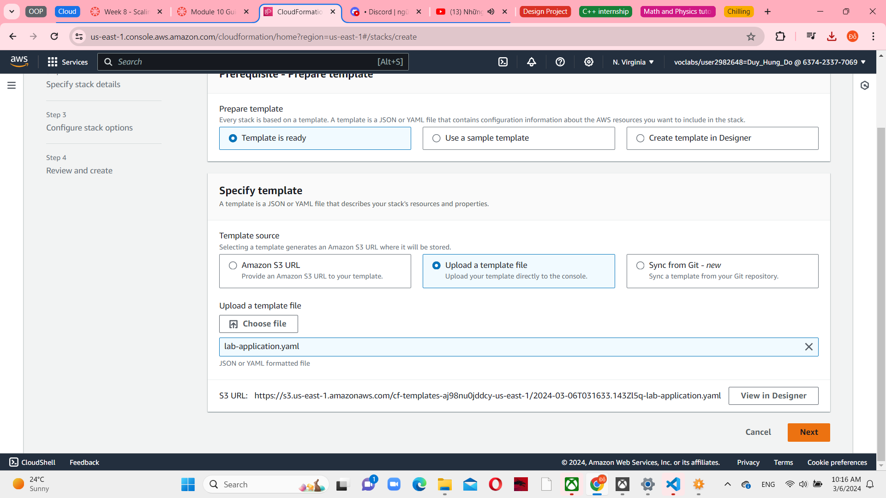

*Figure 13 Specify template*

In step 2, set the stack name is lab-application and the network stack name is lab-network. The parameter "Network Stack Name" in the template designates the name of the initial stack created (lab-network). Consequently, this parameter enables the retrieval of values from the Outputs.

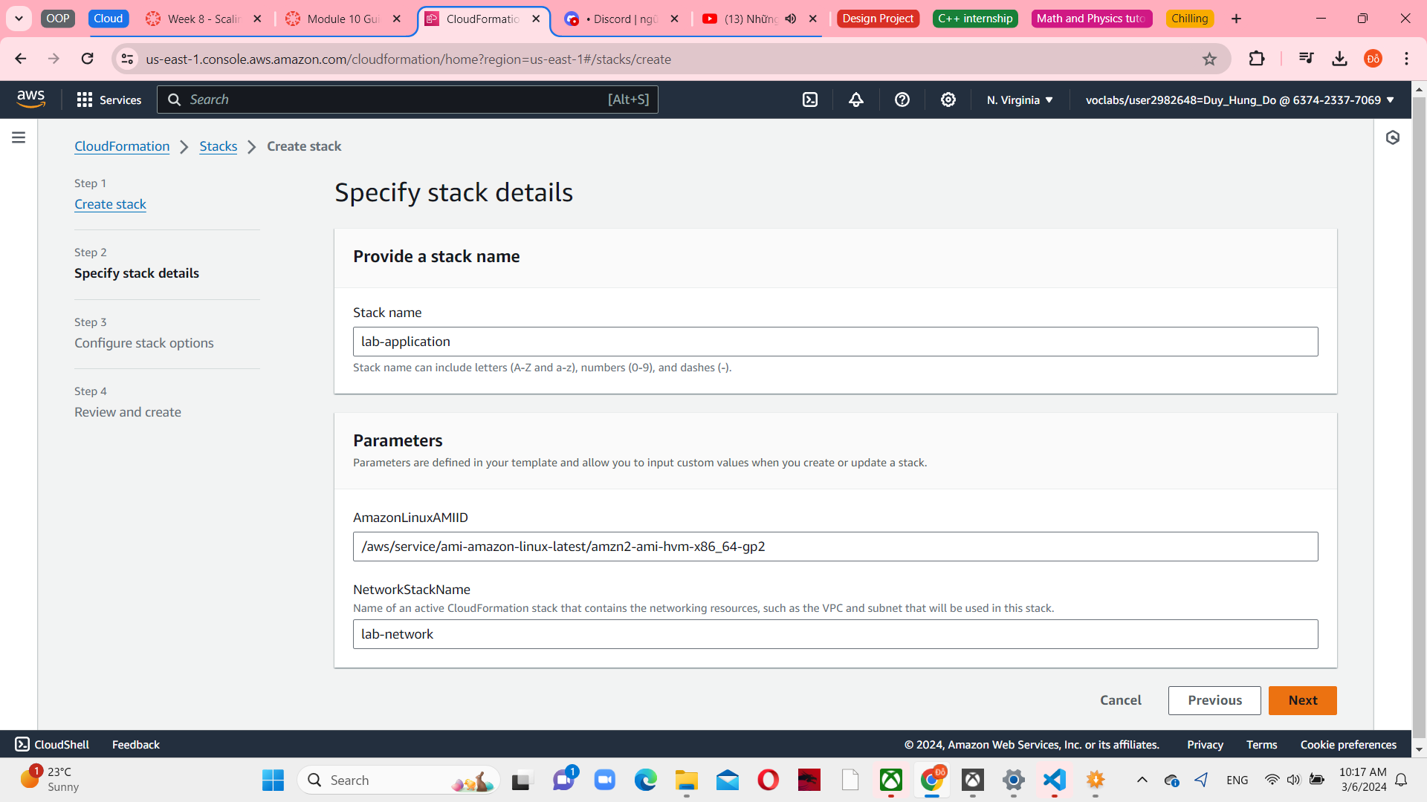

*Figure 14 Specify stack details*

In step 3, config the application as a key and inventory as a value. Before that you have to add new tag.

*Figure 15 Configure stack options*

In step 4, Review lab-application. And then choose Create stack.

*Figure 16 Review and create*

. Examine the details in the Events tab and the Resources tab during the creation of the stack. It is possible to monitor the progress of both the resource-creation process and the resource status. In the Stack info tab, wait for the Status change to complete

*Figure 17 Lab-application create successfully*

Choose the Outputs tab and copy the value as an URL, paste and enter in a new web browser. The browser tab will open the application, which is running on the web server that this new CloudFormation stack created.

*Figure 18 Target group connect with Lab VPC*

A CloudFormation stack can use reference values from another CloudFormation stack. The final line employs the designated network stack name, "lab-network", which was initially specified upon the stack's creation. It imports the value of lab-network-VPCID from the Outputs of the primary stack. Subsequently, it proceeds to insert this value into the VPC ID field within the security group definition. As a consequence, the security group is generated within the VPC that was established by the primary stack.

*Figure 19 Open new AWS CloudFormation web browser*

**Task 3: Updating a Stack**

Choose EC2 from the Services menu, and select Security Groups in the left navigation pane. You can see the inbound rules of lab-application. Currently, only one rule is in the security group. The rule permits HTTP traffic.

*Figure 20 Inbound rules in lab-application*

Choose against CloudFormation and download the lab-application2.yaml for updating. This template has an additional configuration to permit inbound SSH traffic on port 22.

*Figure 21 Stacks in CloudFormation*

Select lab-application from the Stacks list and update it.

*Figure 22 Update lab-application*

Configure replace current template in Prepare template, and upload the lab-application2.yaml file that downloaded.

*Figure 23 Update specify template*

Choose Next in 3 screen after and update the stack. This preview of the change set signifies that AWS CloudFormation will carry out modifications to the WebServerSecurityGroup without necessitating a replacement (Replacement = False). This change set implies that a minor alteration will be made to the security group, and there will be no requirement to update any references to the security group.

*Figure 24 EC2 Instances console*

Return to EC2 console, choose against Security Groups and select lab-application-WebServerSecurityGroup. Click on the inbound rules, the SSH port is added. This subtask exemplifies the ability to implement modifications in a systematic and well-documented manner. The AWS CloudFormation templates can be housed within a designated source code repository, such as AWS CodeCommit. This approach allows for the preservation of various versions and a comprehensive record of the templates and the deployed infrastructure.

*Figure 25 Create image in Web Server 1 Instance*

**Task 4: Exploring templates with AWS CloudFormation Designer**

Choose CloudFormation from the Services menu, and then choose Designer in the left navigation pane. Open the File icon menu and lab-application2.yaml as a local file.

*Figure 26 Opening a template*

Design will display a graphical representation of the template. Instead of drawing a typical architecture diagram, Designer is a visual editor for AWS CloudFormation templates. It draws the resources that are defined in a template and their relationship to each other.

*Figure 27 Representation of application template*

You can experiment with some other features in Resources types. Such as add ACMP to design and connect it by dragging them by some relationships between resources.

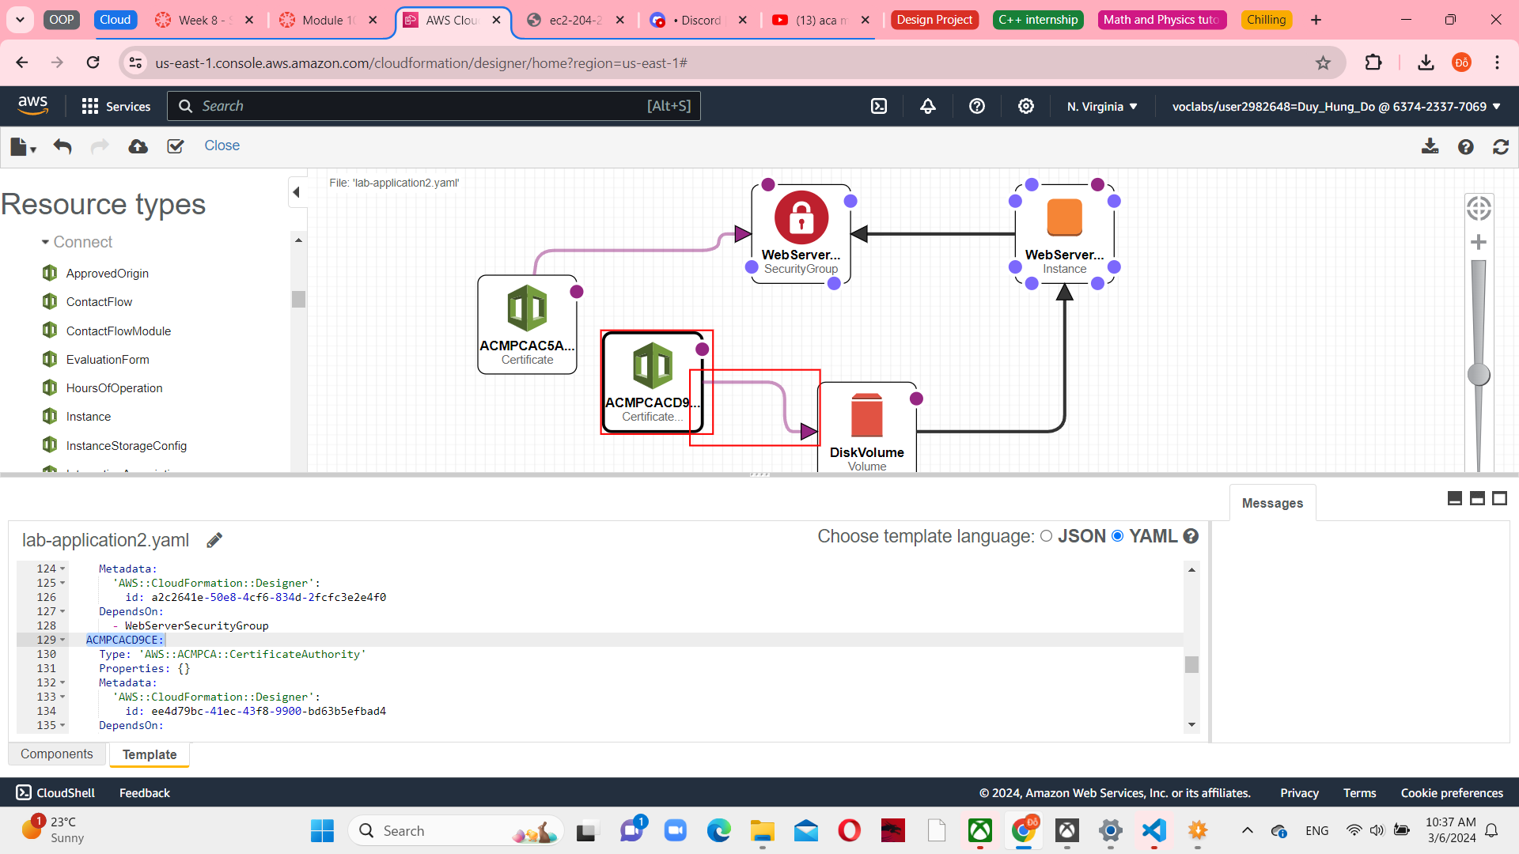

*Figure 28 Relationship between resources*

Open the lab-network.yaml template to explore the resources in Designer.

*Figure 29 Open lab-network.yaml and connect with resources*

**Task 5: Deleting the stack**

Return to the CloudFormation console. In the lists of stacks, choose lab-application link and delete it.

*Figure 30 Delete stack*

Wait for the stack to be deleted. The application stack __ removed, but the network stack remained untouched. This scenario reinforces the idea that different teams (for example, the network team or the application team) could manage their own stacks.

*Figure 31 Deleted lab-application stack*

From the Services menu, choose EC2 again. Select snapshot and see it. It is started time in the last few minutes

*Figure 32 Snapshot console*